HABIT TRACKER APP
@CREATIVITY THINK (9483175986/7019689991)

ABSTRACT:
The Habit Tracker App is a web-based platform designed to help users create, monitor, and maintain personal habits. Users can add habits, set reminders, define goals, and track streaks, with visual dashboard analytics reflecting progress over time. Administrators manage features, moderate logs, and generate analytics dashboards to observe user engagement. Built using Django and Django Rest Framework on the backend and React with Recharts and Axios on the frontend, this app ensures seamless interaction, data security, and real-time updates. It enhances personal productivity and habit formation through structured tracking and actionable insights..

INTRODUCTION OF THE PROJECT:
Forming and sustaining habits can be challenging without structured tracking. The Habit Tracker App provides a centralized web platform where users can set goals, track progress, receive reminders, and monitor streaks through visual dashboards. Administrators oversee feature management, user activity, and analytics reporting. Leveraging Django, DRF, React, Recharts, and Axios, the app delivers a secure, interactive, and responsive experience for both habit users and administrators. This platform fosters habit consistency and self-development with data-driven insights..

PROJECT OBJECTIVES:

• Enable users to define and track personal habits
• Provide reminders and notifications for habit completion
• Monitor habit streaks and goal achievement
• Offer dashboard analytics to visualize progress
• Allow administrators to manage features and track user activity
• Moderate logs and imported habit data
• Provide insights into habit consistency and user engagement

PROBLEM OF THE STATEMENT:
Without structured tracking, users often struggle to maintain habits and achieve personal development goals. Habit management manually is ineffective and lacks analytical insights. Administrators cannot monitor user engagement or effectiveness of features. The Habit Tracker App addresses these issues by providing a centralized platform to create, monitor, and visualize habits, coupled with admin oversight for moderation and analytics..

MOTIVATION OF THE PROJECT:
• Help users build and maintain productive habits
• Provide automated reminders to improve consistency
• Visualize progress and streaks for motivation
• Enable administrators to manage and monitor engagement
• Offer actionable analytics to enhance habit adoption

BLOCK DAIGRAM OF PROJECT:

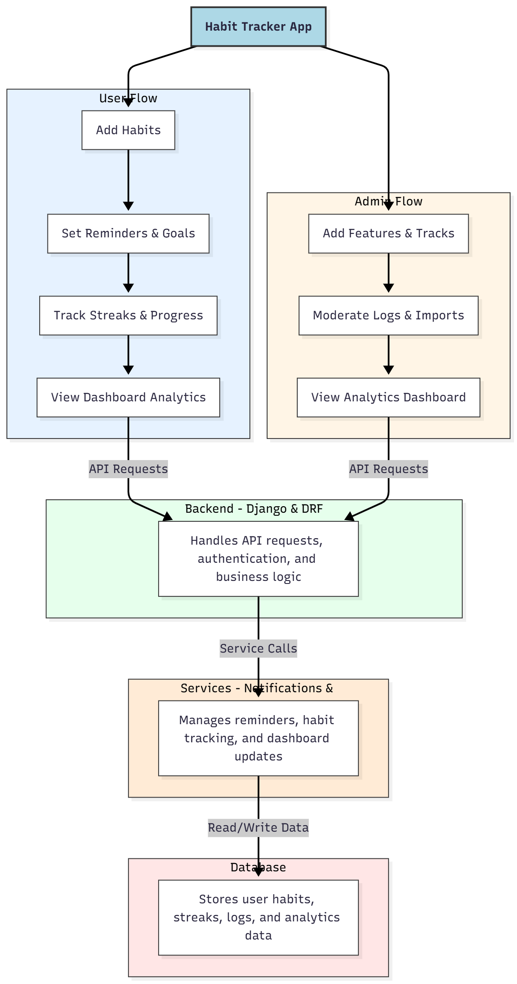

WORKING OF THE PROJECT:
Users log in to add habits, set reminders and goals, track progress, and monitor streaks through dashboards. The backend handles API requests, authentication, and business logic, while services manage notifications, tracking, and analytics updates. Administrators manage features, moderate logs and imports, and review engagement through analytics dashboards. This ensures effective habit formation, consistent tracking, and actionable insights for personal development..

SOFTWARE REQUIREMENT:
- Backend:
  - Python 3.x
  - Django
  - Django REST Framework
  - SQLite/PostgreSQL
- Frontend:
  - Node.js and npm
  - React.js
  - Axios
- Development Tools:
  - Visual Studio Code
  - Postman (for testing APIs)
  - Git/GitHub (for version control)
- Server/Deployment (Optional):
  - Gunicorn, Nginx, or Heroku/AWS for hosting

ADVANTAGES OF THE PROJECT:

• Enables consistent habit tracking
• Provides goal-setting and reminders
• Visualizes progress with streak analysis
• Dashboard analytics for users and admins
• Moderation of user logs and imported data
• Improves personal productivity
• Web-accessible platform for multiple devices
• Actionable insights into habit performance

APPLICATIONS OF THE PROJECT:
• Personal wellness and development
• Corporate productivity programs
• Educational habit tracking
• Fitness habit management
• Self-care routines
• Coaching and mentorship habit tracking
• Data-driven habit improvement
• Behavioral analytics dashboards

REFERENCES:

- Django REST Framework Documentation — Django Software Foundation. Django Documentation. Available: https://docs.djangoproject.com/
- Django REST Framework. DRF Documentation. Available: https://www.django-rest-framework.org/
- React. React Official Documentation. Available: https://reactjs.org/docs/getting-started.html
- Redux. Redux Documentation. Available: https://redux.js.org/introduction/getting-started
- PostgreSQL Global Development Group. PostgreSQL Documentation. Available: https://www.postgresql.org/docs/
- MySQL. MySQL Reference Manual. Available: https://dev.mysql.com/doc/
- Git. Git Documentation. Available: https://git-scm.com/doc
- Node.js. Node.js Documentation. Available: https://nodejs.org/en/docs/
- Axios. Axios Documentation. Available: https://axios-http.com/docs/intro
- Socket.io Documentation – https://socket.io/docs/

